Consequential Interventions for the Casualties of Neo-liberal Globalization
Betty J. Craipo

Senior Capstone - GOVT 490 - Dr. Zeisler-Vralsted - Fall 2013 - Eastern Washington University

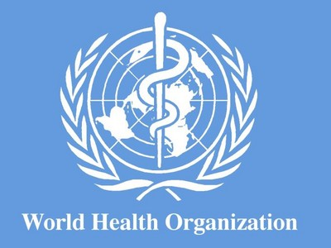
The World Health Organization defines globalization as the increased interconnectedness and interdependence of peoples and countries while also recognizing that globalization has both positive and negative effects (WHO-Globalization, 2013). This definition hints at the necessity to regulate the force of globalization in order to accentuate the positive and minimalize the negative. An Anglo-American agreement was set into place after WWII to attempt to accomplish this objective of global regulation at the Bretton Woods Conference in New Hampshire. This conference, “organized around a set of monetary and trade schemes, amounted to a truly unique historical creation. The agreement embodied a distinctive blend of laissez-faire and interventionism. It allowed the operation of a relatively open system of trade and payments as well as arrangements to support domestic full employment and a social welfare provision.” (Ikenberry, 1993, P.138)
The Bretton Woods Conference attempted to complement market-based fundamentals with set general welfare objectives to stabilize the world economic system for the global poor as well as the global rich. Within a generation, an era of neoliberalism reversed this global general-welfare trend and promoted a deregulated globalization, through “liberalized trade and investment, tax cuts with concurrent cuts in public spending on social services, and an aggressive focus on deregulation and the privatization of state-owned industries or services” (Ayers, 2004, P.12). At this time, casualties of neoliberal globalization were created as global intervention was rescaled from a focus on a stabilizing general-welfare of the world to supply-side competitiveness, as the number of impoverished grew exponentially.
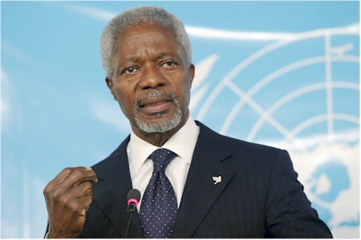
In Kofi Annan’s words, “Throughout much of the developing world, globalization is seen, not as a term describing objective reality, but as an ideology of predatory capitalism. Whatever reality there is in this view, the perception of a siege is unmistakable.” (Annan, 2000, P.127) Neo-liberal globalization is a process that destroys some while elevating others; this process is systemic throughout the global economy and has the potential power to influence every animate, as well as inanimate object on the planet. Neo-liberal globalization is but an acceleration of human interactions that leaves some drowning in the wake of its force and others riding a tremendous wave of wealth and opportunity. The difference between these two representative global actors is their familiarity with the structure of the global system, access to the capital necessary to be a part of that system, and the level of empowerment available to them in their present circumstances: geographically, culturally, or socio-economically.
Numerous studies identify global beneficiaries as well as casualties and how each came to be defined as such. The studies that are missing are those that describe the path necessary for a casualty to become a beneficiary of globalization while still maintaining aspects of themselves that give them identity. Those who have had no means of escaping the destructive, life-altering effects of neo-liberal globalization have had few options other than job loss, land loss, business loss, excessive debt and/or being forced to migrate away from home in order to elevate their standard of living or merely just to survive. The missing aspect here is the intervening force, a force that educates those affected by neo-liberal globalization, offers technical support and training to know the options available, and provides a myriad of optional responses to this real threat. This intervention turns globalization interference into an opportunity, which becomes instrumental to future success.
That intervening force must be present in the local, national, and international realms and be capable of suggesting, not only realistic self-generating and self-perpetuating socio-economic responses, but also having the capacity to follow-up on these individuals without a fixed agenda, a one-size-fits all solution, or having created a relationship of dependency. This paper will bring to light the factors that make maneuvering through the global system so easy for a few and so difficult for so many, while establishing reproducible paths of valuable knowledge and opportunity development that must be created in order to limit the number of neo-liberal globalization casualties.
To define a globalization casualty there must be a workable definition of globalization that can illustrate its ability to affect a group or individual in a negative manner. Globalization is simply an inexpensive movement of information and goods, caused by the ongoing innovation of technology, which has an integrative effect on the entire globe (Bernhagen, 2003, P.257). Inexpensive access to goods and information in a free society would allow all of society to benefit, but these goods and information are being dispersed in a variety of societies in which free access is quite often unavailable. These technological innovations are available to only those with the means to obtain them and that is where the negative effect of globalization becomes apparent.
Access to innovative technologies is the key to being an independent actor in the twenty-first century; there is a technical competence necessary to compete or even subsist in the global economy, without this the chances of becoming a casualty of globalization increases significantly. This necessary global competence has broad scope, but can be broken down into categories that relate to the individuals or groups affected. In the local and national political arena, information disseminated to the leaders, the bureaucracy, and those who are governed, could make communication and cooperation more effective and beneficial to the general welfare of all. In the business world: knowledge of exchange rates, awareness of market signals, and an understanding of how to compete against or just stay clear of multi-national corporations (MNCs), would diminish underdevelopment and decrease the number of failed economies. For those involved in the distribution of food, shared knowledge of what to grow, how to grow it, how to adapt to environmental changes, best practices for transport, and dozens of other avenues could be explored by the head of a supermarket chain as well as a rural farmer, to create an efficient as well as a more equitable system.
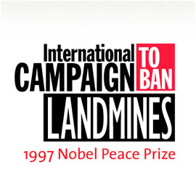
These are just simple examples of turning a casualty of neo-liberal globalization into an independent actor able to flourish in the global system, but without an intervening factor, these examples are just wishes that people have already made that did not come true. Intervention has been a healthy part of political and economic systems for all time, but there have been but a few successful global-scale interventions. These interventions are rare because the issue addressed must create the same response and choice of action by the majority of the global actors. Two examples come to mind, the banning of landmines globally in 1997 and the creation of the International Criminal Court in 1998 (Lechner, 2012 P.325).
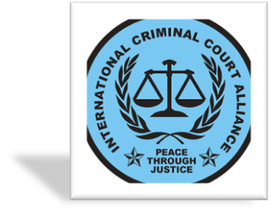
Choosing to disseminate information to every possible corner of the world does not have to be a global decision made by a couple of hundred countries, just a concerted effort on multiple socio- political-economic levels, structured to eliminate the destructive qualities of neo-liberal globalization. Many entities today have disseminated information to needy areas and turned the trajectory of the people’s political, social, cultural, or economic reaction to impending globalizing effects from downward to upward. The intervening groups that have seen the most success have focused, not on poverty, but the root causes of poverty: “growing inequalities, biased resource allocation, and lack of adequate redistributive policies” (UNIHP, 2012, P.27).
Five case studies will be introduced separately to examine the manner in which the actors involved remedied the negative effects of neo-liberal globalization through information dissemination, creating capital-based opportunities, establishing mixed economies, and encouraging universal shared values. The following case studies can serve as potential-future models of intervention while acknowledging that these specific successes are not uniform, but interventions can be derived from these strategies.
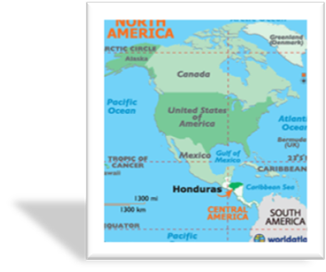
The first study takes place in Honduras and epitomizes the effect that a successful transfer of technology, given in a deliberate and efficient manner, will have on those individuals who were successful before they encountered globalization and began to fail once neo-liberal globalization was introduced to their area. The Rural Development Project for Southern Lempira (PROLESUR) “is funded jointly by the Honduran Government (22 percent) through the Secretariat of Agriculture and Livestock and the Netherlands Government (78 percent) through FAO” (Ismail, 2003, P.11). The third entity in this endeavor is the Food and Agriculture Organization of the United Nations and its “mandate is to improve nutrition, increase agricultural productivity, raise the standard of living in rural populations, and contribute to global economic growth” (FAO, 2013, About).
These two governments with the help of an IO came together in 1988 to intervene locally in Honduras when a combination of drought and poor farming techniques placed rural farmers in a crisis of low field output and lack of land in which to transition. The root of this crisis was globalization; the population increase and the continued inequality in land distribution are typical effects of neo-liberal globalization and are harmful to rural farmers who are not privy to transitional strategies (Hellin, 1999, P.236). The southern Lempira region was no exception to this rule and the regular use of the slash-and-burn farming technique commanded the attention of those local and international agents, which were focused on soil and water conservation. In Lempira, the slash-and-burn farming technique is an age-old method of farming, which is a combination of clearing part of the Honduran Rainforest, burning the vegetation debris that remains after that clearing, and growing crops on that cleared land. This method had minimal effect on the land when the population was small and there was no pressure put on land use or distribution.
The problems that arise from this method is that the land only produces for one to three years and the farmer must move on to clear new land in order to guarantee reliable and stable yields (FAO, 2013, Quesungual). This constant destruction of land has many negative consequences, the rainforest is depleted, the abandoned land cannot return to its previous fertility, and the farmer is forced to work harder and further away for little if any gain. Here is where the intervention occurred, but the intervention, which was instigated in Honduras, was supported by the Honduran government, the Brussels government, and the United Nations, to disseminate information that was available just a couple of hundred miles away.
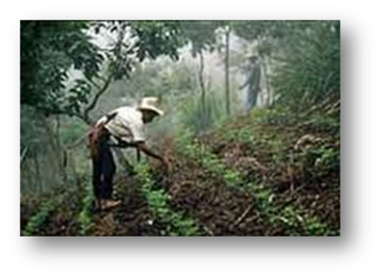
PROLESUR was put into place through many interconnected steps. First, the farmers stopped slashing and burning, which within three years decreased the technique’s use by two-thirds (Bot, 2001, P.43). This first step was just the beginning for the farmers who adopted the Quesungual system, which had been used in western Lempira successfully by the indigenous people for as long as anyone could remember. This system consisted of clearing the land by hand, without burning, and using multiple crops on the same land during different seasons. The land was not totally cleared, leaving numerous old-growth trees, strategically maintained smaller trees, and brush. This diversification and management allowed the soil to be protected from erosion as well as give the crops the light necessary for growth. This system established a sustainable practice for the subsistence of the farmer and his family on one piece of land (FAO, 2013, Rural).
Aside from ending the slash and burn technique, the sustainability of the Quesungual system is found within the planting of three indigenous crops: maize, beans, and sorghum; maize being the first crop planted with beans and sorghum intercropped. All three crops growing together in the first planting to minimalize weeds and eliminate herbicide use, if sorghum is not planted until the second planting then expensive mineral fertilizers do not have to be used; allowing the farmers to use traditional harvesting methods without the need for non-traditional expense (FAO, 2013, Rural). The Quesungual system, by way of an international intervention, allowed the small-rural farmer to care for the land and his family as he adapted to neo-liberal globalization.
At this point, introducing both non-Honduran groups that orchestrated this intervention is necessary. First, the Netherlands Organization for International Development, (SNV) which can introduce itself through its own global aim, “At SNV Netherlands Development Organization we believe that no-one should have to live in poverty and that all people should have the opportunity to pursue their own sustainable development” (SNV, 2013, Home). Secondly, introducing “…the thinking that preceded FAO’s decision to undertake this exercise. The ultimate aim is to improve the quality of community-based nutrition programs by constructing and making available a simple tool that nutrition program planners and implementers can use to assess the likely success and sustainability of an ongoing or planned program, so as to be able to redesign it or make adjustments for improvement” (FAO, 2013, About).
These two groups facilitated real progress in Lempira, not a modernization but a sustainability brought about because the mission statements of two international agents combined to design and implement a sustainable-positive response to neo-liberal globalization. The last factor that came out of this intervention was the construction of metal silos. This addition of capital to store and secure food during the dry summer months in which food scarcity had been prevalent for several years, was the final variable that allowed the community of farmers to keep this process going on their own (Ismail, 2003, P.12). However, the silos alone are not the last factor that has made the PROLESUR project self-perpetuating, the fact that the community is now empowered to the point that they define their own planning processes each growing season, demonstrates their lack of dependence upon those who intervened and thus repositioning their community upon solid, global-empowered ground.
The pattern that is replicable from this case study consists of transferring technology that is conducive to the geographic location, the same environment, and a consistency of crop, culture, and economic foundation. Discovering the technology to be transferred and having a non-profit disseminate the information to the area in crisis, through indigenous-technological transfer and non-dependency capital infusion, made possible the technical innovation necessary to bring about adaption to the process of neo-liberal globalization for a community. PROLESUR brought a community, with limited institutions and infrastructure, out of crisis and into a sustainable standard of living, producing a workable model for future interventions.
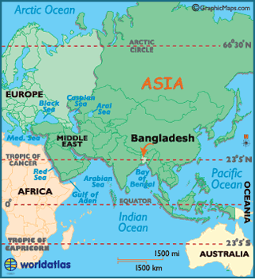
The next study takes place in rural Bangladesh and is presented in order to highlight how intervention through opportunity creation can be successful even when those opportunities are given to the “ultra-poor”. These people are the poorest of the poor who are marginalized to the point in which they are unable to “benefit from, and participate in, existing development programs that facilitate access to market activity” (Mair, 2009, P.425). This study was a continuation of many interventions that have been orchestrated since Bangladesh declared its independence from India in 1971. The heart of those interventions is the Bangladesh Rural Advancement Committee (BRAC) that developed a twin-purpose development strategy, alleviating poverty while empowering the poor (Mair, 2009, P.424).
The key to this type of intervention is micro-credit, “a form of credit offered to the ‘very poor’ as a way to generate income from micro-enterprises and, by extension, to reduce poverty among those most disenfranchised in the global political economy” (Aitken, 2013, P.474). After thirty years of intervening in Bangladesh, BRAC discovered that there were barriers to reaching the ultra-poor that were fundamentally different from the barriers encountered for the higher strata of the impoverished. These barriers included all four societal domains: cultural, social, and political, as well as economic (Mair, 2009, P.425).
In 2002, Challenging the Frontiers of Poverty Reduction program (CFPR) was established within BRAC to take on those barriers to the ultra-poor (Mair, 2009, P.421). CFPR identified structural issues within social domains that kept the ultra-poor from receiving assistance from programs that had assisted those less poor within Bangladesh. These barriers included historic attitudes of the elite, beliefs of the dominate religion, corruption of the judicial and administrative officials, and the rigidity of previous micro-credit opportunities. CFPR addressed all of these institutional and societal elements and established a repeatable model for future interventions in extreme circumstances.
To begin analyzing the study, the inability to create opportunities for economic growth in rural Bangladesh is most easily seen in the social structure of the people. The lack of social capital of the ultra-poor, a vacuum of personal relationships necessary to access social or economic mobility, excludes this stratum of society from beneficial intervention. A sample of the ultra-poor demonstrates that seventy-five percent lacked access to relationships that would be beneficial. “Only one-fourth of the sample had access to any kind of capital, and of these only about twenty percent received a loan from any institutional source, the others depending on informal loans from relatives, friends, and moneylenders” (Halder, 2004, P.392).
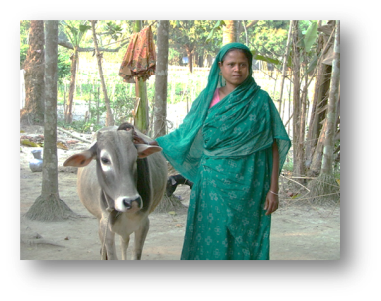
CFPR’s reaction to this data was to challenge the religious, political, and social agents within Bangladesh to fulfill societal obligations to these people while CFPR restructured the way in which micro-credit was offered. The way in which micro-credit had been offered to the ultra-poor in the past had caused friction within Bangladesh. With the dominant religion being Islam, micro-credit that had been offered in the past, allowing women to be independent of the home was condemned as a perversion to religious beliefs. Obeying Purdahbecame a clear objective for CFPR and how micro-credit was offered to women was transformed.
Ultra-poor women were offered capital assistance to purchase and rear poultry and livestock and to cultivate crops in order to build their physical asset based which would not require them to leave the home (Mair, 2009, P.427). Honoring the beliefs of Islam allowed this type of opportunity to be available to the ultra-poor but understanding the five pillars of Islam allowed CFPR to enfranchise so many more by prodding the elite to do their part. This friendly reminder that Islam teaches that the elite have a moral obligation to help those in need countered the social norm of the elite only giving aid to those from whom they could also profit (Mair, 2009, P.430). This profit-gaining motive leads the study toward the corruption found within the judicial and administrative institutions within Bangladesh.
In Bangladesh, there are two ways of settling disputes or being heard, the formal and informal systems. The ultra-poor have limited access to either due to their inability to pay the bribes necessary or due to the extensive waiting period for any type of resolution (Mair, 2009, P.426). In rural areas, the formal system is not available and the shalish brings little assistance. “As a BRAC Social Development program coordinator informed us: We have been long trying to engage our members in these traditional forms of dealing with conflicts [shalish]… but it is very difficult since they are dominated by the male elite, which makes women's participation rather limited, and also presents high levels of corruption” (Mair, 2009, P.427). Thus, being heard in Bangladesh takes money or non-state intervention, CFPR provided both.
The next step CFPR took to intervene was creating Village Organizations (VOs). In order to empower the ultra-poor, CFPR needed to build social capital, needed to organize the most unheard, the women. VOs “are made up of 35 to 50 women from a single village. Typically, VO members are involved in microfinance programs and meet every week with a BRAC program organizer to learn about health issues, discuss several economic, social, and legal issues that affect their lives. VOs become the arena in which the powerless are able to express and explain their problems, participate in the community, and receive services” (Mair, 2009, P.429).
Through these meetings, the rigid structure of previously offered micro-credit was discussed and the CFPR created more flexible, smaller repayments for micro-loan recipients. When tallying all of these interventions together, a pattern emerges that is repeatable. BRAC uses Levi Strauss’ original concept of bricolage, which is “making do by applying combinations of the resources at hand to new problems and opportunities” (Mair, 2009, P.423). This strategy was the factor that changed the game for the ultra-poor in Bangladesh. Combining pertinent knowledge of the prevailing religion, the necessary obedience to social norms, an understanding of the weak institutions involved, and the power of organizing the unheard with an NGO that has goals of ending poverty and dependence is a repeatable model for future interventions that create capital-based opportunities.
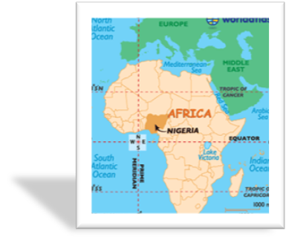
The next case study takes place in Nigeria and is being introduced to demonstrate redistributive policies implemented by the Nigerian government that decrease income gap by way of Small-Scale Enterprise investment (SSE) and Small and Medium-Scale Enterprise investment (SME). Wealth inequality in the world has been exacerbated by neo-liberal globalization due to the impact this variable has had on “an increasingly integrated world economy, typified by growing capital mobility, heightened international competition, and an increase in migration” (Alderson, 2001, P.1244).
The Nigerian government, beginning in the 1970s after becoming independent and coming through a bloody civil war, took a step toward reducing poverty by transferring control of foreign enterprises to indigenous owners; this act was called the Indigenization Decree of 1972 (Dachi, 1999, P.90). This decree along with subsequent reforms hoped to improve employment, increase indigenous entrepreneur numbers, expand the use of local resources, and reduce the migration tendency of rural to urban settings (Dachi, 1999, P.77). By the 1980s, after emerging from the Import Substitution model and falling into the global debt so many developing states found themselves in, Nigeria adopted the Structural Adjustment Program.
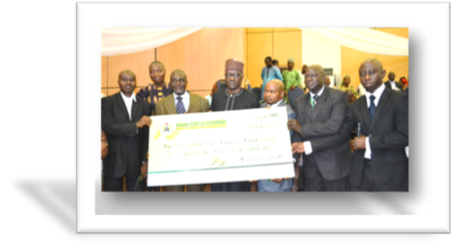
This program was found to be ineffective in regards to closing the wealth gap in Nigeria and a study done for the second meeting of the Nigerian Development Plans concluded that an additional step must be taken toward SSE development. “The central philosophy of the SMEs policy was based on the belief that the industrial take-off of any nation, most especially the developing economies in the Third World, depended to a greater extent on the successful take-off of SMEs” (Dachi, 1999, P.78/91).
One result in this change of policy is evident in the make-up of the Nigerian economy, seventy-five percent of the employment in Nigeria is provided by small and medium-scale enterprises. Paradoxically, sixty percent of the population lives in relative or absolute poverty (Aremu, 2011, P.204). The model that Nigeria provides, although drastically less effective than if it were in a developed state, acknowledges certain steps that must be taken to have bottom-up development for unskilled labor, which allows the worker to remain near their home; Structural Adjustment Programs only provided jobs for skilled workers and have a high-frequency migration rate (Dachi, 1999, P.165). Nigeria’s example of creating SMEs consists of investing in small enterprises without disinvesting in large enterprises, creating special financial institutions that focus solely on SMEs, and decreasing the export of local resources in order that those resources can produce jobs for the indigenous people, slowing the trend toward migration. As of 2006, Small and Medium Enterprises in Nigeria currently account for over 75 percent of employment in the country (Aremu, 2011, P.204) proving the sustainability of this intervention.
Before the last case studies are introduced, a simple review of the previous case studies will help focus the necessity of consequential interventions and the factors necessary for the ultimate success of those interventions. The Honduran case study proved that even minimal information dissemination; if timed properly, correctly related to the problem, and supported by the community, negates the predictable outcome for farmers that neo-liberal globalization will confiscate or degrade their fields and relegate them to urban workers. The Bangladesh case study proved that even minimal capital infusion; if made flexible enough for the individual/group it was meant to help, honored religious beliefs, respected social norms, and was portrayed as beneficial to the general good, negates job loss, land loss, and urban migration that casualties of neo-liberal globalization experience without such intervention. The Nigerian case study proved that minor policy adjustments; if backed by data over time and kept focused on small economic actors as well as the larger economic picture, creates a dynamic economic environment that supports the scope of entrepreneurship in Nigeria. These three case studies provide numerous tools for governments and institutions that want to intervene on the part of individuals/groups, who are slowly becoming casualties of neo-liberal globalization or who have already been displaced in its wake.
These case studies identified intervening factors that are accessible options to lessen the pull of poverty in this era of neo-liberal globalization for their particular circumstances, but a fourth factor is mandatory, and that is to create a collective identity. “A collective identity gives movement actors a sense of “we-ness” as they begin to attribute their personal experiences to larger structural issues” (Brumley, 2013, P.136). This desire for collective identity is found on both sides of the intervention, whether you are the rural poor or the CEO of an NGO, taking the steps necessary to involve others, to make a collective effort to respond to neo-liberal globalization is the key to neutralizing its negative effects. The following case studies expand on this collective-effort response to the negative effects of neo-liberal globalization by focusing on internal interventions through social movements. The first will show how a small group of Mexican farmers in economic crisis organized and collectively identified themselves as responsible debtors and transformed themselves into solvent, engaged citizens. The second case study will show how the rural poor in Thailand organized to protect their local livelihood and environment.
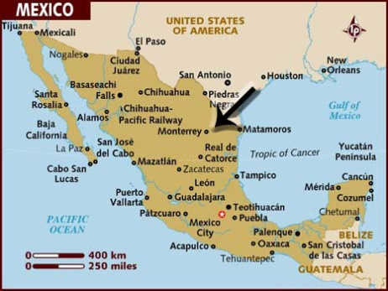
The Mexican case study takes place in Monterrey, Mexico and is presented in order to demonstrate the side of collective identity that was necessary to respond to the devastating blow neo-liberal globalization had on the rural Mexican farmer, organize or lose everything. “For Mexico’s subsistence farmers, agrarian reform meant there was no more land to distribute, and with that, the peasant dream of owning land ended. In contrast, the government promoted large commercial agriculture in preparation for the North American Free Trade Agreement (NAFTA), which established Mexico in the global economy.” (Brumley, 2013, P.140) The type of intervention that came in Monterrey was not from an IO, NGO, or national government, but from middle-class business leaders who were also affected by this crisis, and saw the need to act collectively, to fight the debt crisis (Brumley, 2013, P.141). This movement went by the name El Barzón and was founded by the principle that debtors would pay back a fair compromise of what they owed because the process by which they accrued this debt was due to unfair economic and banking policies (Brumley, 2013, P.145).
As this paper has demonstrated in previous case studies, there must be structure to an intervention or it will be short-lived and not remedy neo-liberal globalization problems. The structure created by El Barzón produced a collective identity of those affected by taking three specific steps: creating boundaries, giving meaning to those boundaries, and negotiating context (Brumley, 2013, P.138). The boundaries listed were those between the groups that benefited from neo-liberal globalization and the groups that were harmed. Clearly identifying both groups and establishing that one group was responsible for the negative effects of neo-liberal globalization, offered a path to a collective mindset, which was furthered when the meaning of that boundary was augmented by organized protests and unifying activist events (Brumley, 2013, P.138). The final step is that of negotiation, negotiating the daily message of El Barzón to remain within the intended collective identity, while dealing with the ever-changing political environment in which it challenged.
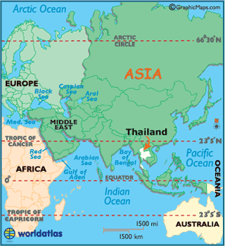
Without this intervention, the solution that was recommended by the Mexican government, ‘work and save’, could have never been orchestrated for the thousands of Mexicans who were already unemployed; they would have lost everything. Consequently, the most devastating effects of neo-liberal globalization are the loss of human capital for the individual and the loss of social capital for groups. El Barzón became the intervening force that mitigated the human capital loss and created the structure necessary to produce social capital, therefore, negating the negative effects of neo-liberal globalization. The overwhelming evidence of social capital gains present after this intervention proves its success and sustainability. When the economic crisis was resolved, Barzonistas transformed their message from that of debtors challenging an oppressive economic structure to citizens with a “central role in resolving Mexico’s problems” (Brumley, 2013, P.159).
The last case study takes place in Thailand and demonstrates another side of the necessity for creating a shared identity in fighting the effects of neo-liberal globalization, and that is the collective action of numerous NGOs, rural villagers, and slum dwellers. Unlike the Mexican intervention that was led by businessmen, the Honduran intervention that consisted of two governments and a single NGO, and the Bangladeshi and Nigerian interventions that were government orchestrated, the Thailand intervention was orchestrated by a vast array of NGOs, reflecting their activist history.
“Thailand has a long history of rural resistance and organized rebellion. Rural resistance in pre-modern times appeared in the form of a Buddhist-oriented millenarian movement, known as ‘holy men revolts,’ or kabot phu mi bun. The beginning of rural resistance in modern Thai history is closely linked with communist movements in the country” (Chalermsripinyorat, 2004, P.542). This resistance history combined with the neo-liberal globalization effects that devastated Thailand created a perfect storm of activism that consumed the 1990s. The ‘Assembly of the Poor’ was developed in a conference of Thai NGOs and created the ‘Mun River Declaration’. This declaration was a petition given to the Thai government, just one of many, which were used as negotiating tools, along with massive demonstrations and public media coverage (Missingham, 2004, P.320). These negotiations fared well due to the structural strength of this NGO and individual protestor pact.
This paper has demonstrated the transformation of many neo-liberal globalization casualties into independent actors by way of a myriad of routes, but all of the routes contained guiding factors of intervention. These guiding factors were unique for all the problematic situations; however, they all relied upon the creation of a shared identity in which to rally around. Whether that identity was instigated by those individuals/groups who were harmed, or an outside agent that saw harm and chose to take structured action. The collectivity of the action was crucial in every case study and with the plethora of case studies reviewed that produced limited or no positive results from intervention, it was easily concluded that without a collective identity, structure alone could not produce sustainable, positive results.
In addition to a collective identity, this paper demonstrated that interventions that focus on the root causes of poverty: “growing inequalities, biased resource allocation, and lack of adequate redistributive policies” (UNIHP, 2012, P.27), when combined with a structural aspect that honors the prevailing religion: the necessary obedience to social norms, an understanding of the weak institutions involved, can be successful. The negative effects of neo-liberal globalization can be remedied through interventions that disseminate information, create capital-based opportunities, promote redistributive policies, and consist of the universally shared value of a collective identity. Globalization is a tool, like any tool, in the wrong hands is a weapon, but in the right hands is a force for good.

Bibliography

Aganga, O. (July 2013) Nigerian Government to tackle unemployment. Voice of Nigeria. Retrieved from http://www.voiceofnigeria.org/Nigeria/Nigerian-Governmet-to-tackle-unemployment.html

Aitken, R. (2013). The Financialization of Micro-Credit. Development & Change, 44(3), 473-499.

Alderson, A. S., & Nielsen, F. (2001). Globalization and the great U-turn: Income inequality trends in 16 OECD countries. American Journal Of Sociology, 107(5), 1244.

Ali, S. R., Liu, W. M., & Humedian, M. (2004). Islam 101: Understanding the Religion and Therapy Implications. Professional Psychology: Research and Practice, 35(6), 635.

Annan, K. (2000). The politics of globalization. Globalization and the challenges of a new century, 125-131.

Appadurai, A. (2013). The Future as cultural fact: Essays on the global condition. London: New York : Verso Books.

Appadurai, Arjun. (2013). The Future as cultural fact: essays on the global condition. London: New York : Verso Books.Tickner, Arlene B.; Blaney, David L. (2013). Claiming the International. Retrieved from http://www.eblib.com

Aremu, M.A. and Adeyemi, S.L. (2011). Small and Medium-Scale Enterprises as A Survival Strategy for Employment Generation in Nigeria. Journal of Sustainable Development, 4(1), 200 – 206.

Ayres, J. M. (2004). Framing collective action against neoliberalism: The case of the “anti-globalization” movement. journal of world-systems research, 10(1), 11-34.

Bernhagen, P. (2003). Is globalization what states make of it? Micro-foundations of the state-market condominium in the global political economy. Contemporary Politics, 9(3), 257-276.

Bot, A. & Benites, J. (2001). Conservation agriculture : case studies in Latin America and Africa. Rome: Food and Agriculture Organization of the United Nations, Print.

Brumley, K. M. (2013). From Responsible Debtors to Citizens: Collective Identity in the Debtors’ Movement in Monterrey, Mexico. Journal Of Contemporary Ethnography, 42(2), 135-168.

Chalermsripinyorat, R. (2004) Politics of Representation: A Case Study of Thailand's Assembly of the Poor. Critical Asian Studies 36(4):541-566.
Chen, M.A., (1983). A quiet revolution: Women in transition in rural Bangladesh. Shenkman Books, Rochester, VT.

Cole, J. & Durham, D. (2007) Generations, and globalization: youth, age, and family in the new world economy Bloomington: Indiana University Press

Dachi, M. S. (1992). The role of small-scale enterprises in reducing poverty and income inequality in Africa: a case study of manufacturing industries in Nigeria (Doctoral dissertation, University of London).

Etzkowitz, H., & Klofsten, M. (2005). The innovating region: toward a theory of knowledge‐based regional development. R&D Management, 35(3), 243-255.

Etzkowitz, H., & Leydesdorff, L. (1996). A triple helix of academic-industry-government relations: Development models beyond 'capitalism versus socialism'. Current Science, 70, 8, 690.

Food and Agriculture Organization of the United Nations (2013) About. FAO. Retrieved from http://www.fao.org/about/en/

Food and Agriculture Organization of the United Nations (2013) The Quesungual agroforestry farming system. Retrieved from http://www.fao.org/focus/e/honduras/agro-e.htm

Food and Agriculture Organization of the United Nations (2013) Rural communities actively implementing conservation agriculture Retrieved from http://www.fao.org/docrep/003/y1730e/y1730e04.htm

Freire, P. (2000). Pedagogy of the oppressed. Continuum International Publishing Group

Ghai, D. (2008). UN contributions to development thinking and practice. Development In Practice, 18(6), 767-773.

Golub, S. (2003). Non-state justice systems in Bangladesh and the Philippines. Department for International Development (DFID), January.

Halder, S. R., & Mosley, P. (April 01, 2004). Working with the ultra-poor: learning from BRAC experiences. Journal of International Development, 16, 3, 387-406.

Hassan, R. (2012). The knowledge deficit: Liquid words as neo-liberal technologies International Journal of Media & Cultural Politics, 8(2/3), 175-191.

Hellin, J., William, L. A., & Cherrett, I. (1999). The Quezungual system: an indigenous agroforestry system from western Honduras. Agroforestry Systems, 46(3), 229-237.

Ikenberry, G. J. (1993). The political origins of Bretton Woods. In A retrospective on the Bretton Woods system: Lessons for international monetary reform (pp. 155-198). University of Chicago Press.

ICBL (2013) Ban History. International Campaign to Ban Land Mines. Retrieved from http://www.icbl.org/index.php/icbl/Treaty/MBT/Ban-History

Ismail, S., Immink, M., Mazar, I. & Nantel, G. (2003). Community-based food and nutrition programs: What makes them successful? A review and analysis of experience. Food and Nutrition Division, Food and Agriculture Organization (FAO). Rome: FAO.

Jessop, B. (2002). Liberalism, neoliberalism, and urban governance: A state–theoretical perspective. Antipode, 34(3), 452-472.

Jonas, K. J., & Morton, T. A. (2012). Restoring Civil Societies: The Psychology of Intervention and Engagement Following Crisis. Chichester: Wiley.

Katz, J. (2004). Market-oriented Reforms, Globalization and the Recent Transformation of Latin American Innovation Systems. Oxford Development Studies, 32(3), 375-387.

Kirdar, U., & Silk, L. S. (1994). A World fit for people: Thinkers from many countries address the political, economic, and social problems of our time. New York: New York University Press.

Lechner, F. & Boli, J. (2012) The globalization reader Chichester, West Sussex Malden, MA: J. Wiley & Sons

Mair, J. Marti, I. (Sept. 2009) Entrepreneurship in and around institutional voids: A case study from Bangladesh, Journal of Business Venturing, Volume 24, Issue 5, 419-435

Matin, Imran, et al (2008), Crafting a Graduation Pathway for the ultra-poor: Lessons and Evidence from a BRAC Programme, RED Working Paper, BRAC.

Missingham, B. (2003). Forging solidarity and identity in the assembly of the poor: from local struggles to a national social movement in Thailand. Asian Studies Review, 27(3), 317-340.

Oxford Dictionary (2013) Retrieved from http://www.oxforddictionaries.com/us/definition/american_english/microenterprise

Patnaik, Prabhat. (2011) Globalization and Social Progress. Social Scientist , Vol. 39, No. 1/2 pp. 47-59

Powell, E. & Mitchell, S. (2008) The Creation and Expansion of the International Criminal Court: A Legal Explanation. Paper presented at the 66th Annual Meeting of the Midwest Political Science Association, April, Chicago, Il.

Sen, Amartya (1999). Development as freedom New York: Knopf

Slater, R., Schutz, B. & Dorr, S. (1993) Global transformation, and the Third World Boulder London: L. Rienner Publishers Adamantine Press

SNV Netherlands Development Organization (2013) Home. Retrieved from http://www.snvworld.org/

Stehr, N., Ufer, U. (2009). On the global distribution and dissemination of knowledge International Social Science Journal, 60(195), 7-24

Talbott, J., & Roll, R. (2001). Why Many Developing Countries Just Aren't. The Anderson School at UCLA, Finance Working Paper, (19-01).

Tsai M, Chang H, Chen W. Globally Happy: Individual Globalization, Expanded Capacities, and Subjective Wellbeing. Social Indicators Research October 2012 108(3):509-524.

United Nations Educational, Scientific, and Cultural Organization (UNESCO). (2012). The United Nations Intellectual History Project: An Inside View. Retrieved from http://www.unesco.org/afus/LIEN/b98/5_UNIHP.pdf

United Nations Educational, Scientific, and Cultural Organization (UNESCO). (2012). Building Knowledge Societies. Retrieved from http://en.unesco.org/themes/building-knowledge-societies

Walters, W. (2012). Governmentality: Critical Encounters. Hoboken: Taylor and Francis.

Weiss, T. G. (2012). What's wrong with the United Nations and how to fix it. Cambridge, UK: Polity.

WHO (2013) Trade, foreign policy, diplomacy and health - Globalization. World Health Organization. Retrieved from http://www.who.int/trade/glossary/story043/en/

WHO (2013) Trade, foreign policy, diplomacy and health - Structural Adjustment Programmes (SAPs). World Health Organization. Retrieved from http://www.who.int/trade/glossary/story084/en/

As a new economic project oriented to new conditions, neoliberalism calls for: the liberalization and deregulation of economic transactions, not only within national borders but also—and more importantly—across these borders; the privatization of state-owned enterprises and state-provided services; the use of market proxies in the residual public sector; and the treatment of public welfare spending as a cost of international production, rather than as a source of domestic demand. As a political project, it seeks to roll back “normal” (or routine) forms of state intervention associated with the mixed economy and the Keynesian welfare national state (or analogous forms of intervention in the developmental state or socialist plan state) as well as the “exceptional” (or crisis-induced) forms of intervention aimed at managing, displacing, or deferring crises in and/or of accumulation regimes and their modes of regulation in Atlantic Fordism, East Asia, and elsewhere. It also involves enhanced state intervention to roll forward new forms of governance (including state intervention) that are purportedly more suited to a market-driven (and, more recently, also allegedly knowledge-driven) globalizing economy. This typically involves the selective transfer of state capacities upwards, downwards, and sideways, as intervention is rescaled in the hope of securing conditions for a smoothly operating world market and to promote supply-side competitiveness on various scales above and below the national level (Jessop, 2002, P.3).
"The primary objectives [of the conference]...were to develop a declaration that states would sign signaling their intention to ban antipersonnel mines and an "Agenda for Action" outlining concrete steps to reach such a ban. …the Canadian government challenged the world to return to Canada in a year to sign an international treaty banning antipersonnel landmines. Members of the International Campaign to Ban Landmines erupted in cheers... It was really breath-taking." (ICBL, 2013)
The process of lengthy and meticulous negotiations resulted in the final text of the Rome Statute, which was approved by 120 states voting in favor, 7 states voting against the Treaty, and 21 states abstaining from the vote (Schabas 2004, 18).2 The International Criminal Court came into existence as an independent, permanent court with the ability to try persons accused of the most serious crimes against humanity. The ICC Statute requires that all State Parties accept the Court’s jurisdiction over all crimes: genocide, crimes against humanity, war crimes, and aggression.3 The Statute came into force on July 1, 2002, when 60 state parties had ratified the treaty, a figure that has grown to over 50% (105 countries) of all states today (Powell, 2008).
The term ultra-poor was first used by Michael Lipton (1983), where he defined the ultra-poor as those who spend 80% of their total expenditure on food and cannot attain 80% of their standard calorie needs (Matin, 2008, P.4).
Micro-enterprise is a business operating on a very small scale, especially one with a sole proprietor and fewer than six employees (Oxford, 2013).
Purdah literally means ‘curtain’. It refers to the obligation – for women only – to stay close to their family groups, visit primarily with female friends, and to forgo public places such as the village market where they might purchase food or clothing (Chen, 1983, P.58).
The third pillar of Islam is called Zakat, the alms tax. Zakat originally meant self-purification and was not just a charitable act but was considered a “loan to God.” The idea behind Zakat is that it is not only a form of worship, but also that Muslims give money to rectify social inequalities. The most common estimate of Zakat practiced among Muslims in the United States is that 2.5% of all savings and earnings are donated annually. This percentage is to be given to the less fortunate and is commonly paid at the end of the month of Ramadan (Ali, 2004, P.637).
Male domination of the judicial institutions and administration, along with their weakness, slowness and corruption make the legal protection of women meaningless. The majority of poor people – this is true in general but particularly acute for the ultra-poor – cannot rely on the formal system because they cannot afford to pay bribes nor wait eternally for dispute settlements. This explains why in rural areas informal means of resolving disputes are preferred. The informal legal system – called shalish, which means mediation – is generally favoured for its lower cost, speed, accessibility and cultural relevance (Mair, 2009, P.426-7).
Bangladesh features widespread use of a community-based, non-state dispute resolution technique, shalish, in three broad forms: as traditionally administered by village leaders and other influential persons, including religious figures; as modified through national legislation and accordingly administered by a local government body, the union parishad (UP);3 and as modified and overseen by NGOs in many parts of the country (Golub, 2003, P.1).
According to the document (the New Industrial Policy launched by President Ibrahim Babangida at Abuýj, throughout most of the post-Independence era, Nigeria pursued an import substitution industrialization strategy. The hallmarks of this policy were the heavy reliance on the public sector to undertake "ambitious and often costly industrial projects” with little inputs from the private sector. The statement also noted that the structure of manufacturing industry that emerged was highly distorted and heavily skewed with high geographical concentration, high import content and high production costs; low value-added, low capacity utilization and a corresponding low level of foreign investment (Dachi, 1999, P.89).
From mid. 1981, the world oil market prices began to collapse ushering in economic crisis in Nigeria. Decline in oil exports and prices led to declines in foreign exchange. This drop in oil revenue triggered other developments. External revenue fell sharply and foreign debts mounted in the face of rising exports. The immediate effect of this was the widening of government deficits (Dachi, 1999, P.149).
Structural Adjustment Programs (SAPs) are economic policies for developing countries that have been promoted by the World Bank and International Monetary Fund (IMF) since the early 1980s by the provision of loans conditional on the adoption of such policies. Structural adjustment loans are loans made by the World Bank. They are designed to encourage the structural adjustment of an economy by, for example, removing “excess” government controls and promoting market competition as part of the neo-liberal agenda followed by the Bank. The Enhanced Structural Adjustment Facility is an IMF financing mechanism to support of macroeconomic policies and SAPs in low-income countries through loans or low interest subsidies (WHO, 2013, http://www.who.int/trade/glossary/story084/en/).
Structurally, the Federal Government created the Small-Scale Industries (SSIs) Division in the Federal Ministry of Industries with the responsibility of the formation of policy, planning, supervision, and execution of the small and medium scale industries development in Nigeria. Other responsibilities of the organization included financial assistance, provision of extension services, commissioning of potential surveys, training of employees of SSEs and extension offices (Dachi, 1999, Pp.78-9). It was out of these circumstances that the concept of a National Economic Reconstruction Fund (NERFUND) was formulated. The concept became a law in January 1989 (Dachi, 1999, P.88)
Since the early 1960s, economic development and industrialization have transformed Thailand’s economy and social structure, undermining the importance and security of the agricultural sector, exacerbating economic inequality and bringing about new forms of exploitation. Development engendered a social and environmental crisis in the countryside as the state and capital increasingly moved to acquire and exploit rural environmental resources such as land, forests and rivers, especially from the early 1980s (Missingham, 2003, P.319).

